**QA Task**

Please access the following sample application - [http://computer-database.herokuapp.com/computers](https://slack-redir.net/link?url=http%3A%2F%2Fcomputer-database.herokuapp.com%2Fcomputers) 218

1. Create a series of manual test cases that cover the CRUD operation plus the edge cases. Make sure you give detailed instructions for each test case (pre conditions, steps, expected results). You can use any format you want.
2. Write scripts that would automate the manual test cases that you see fit to be included in a regression test set. Please use any of below programming languages:

* Javascript (preferred)
* Java (preferred)
* Python
* Ruby

3. Then the assessment is completed, please push the file containing the manual test cases and the automation project to GitHub.

Please don’t spend longer than 60/90 minutes max on this task.

**Part 1**

|  |  |  |
| --- | --- | --- |
| **Test Case ID:** | | 1 |
| **Title:** | | Verify a user is able to Create a computer |
| **Preconditions:** | | * Website: <http://computer-database.herokuapp.com/computers> is running and available to the user |
| **#** | **Steps** | **Expected Results** |
| 1 | Open URL: <http://computer-database.herokuapp.com/computers> | User is navigated to the home page of the application with the title: ‘[x] computers found’, where ‘x’ is an integer value in the range 0-n. |
| 2 | Select ‘Add a new computer’ button | User is navigated to the ‘Add a computer’ screen |
| 3 | Populate the following fields: ‘Computer name’ ‘Introduced name’ ‘Discontinued date’ | Fields are correctly populated with data. |
| 4 | Set a value from ‘Company’ drop down | Value selected from ‘Company’ drop down |
| 5 | Select ‘Create this computer’ button | User is navigated back to the home page of the application with the title: ‘[x] computers found’, where ‘x’ is an integer value in the range 0-n. |
| 6 | Verify a message stating: ‘Done! Computer [x] has been created’ shows on the home page, where ‘x’ is the name of the computer created | Message stating: ‘Done! Computer [x] has been deleted’ shows on the home page, where ‘x’ is the name of the computer created |
| 7 | Check that the new Computer has been added to the grid of computers and the following details are correctly populated with the values used to create the computer: ‘Computer name’ ‘Introduced’ ‘Discontinued’ ‘Company’ | The new Computer has been added to the grid of computers and the following details are correctly populated with the values used to create the computer: ‘Computer name’ ‘Introduced’ ‘Discontinued’ ‘Company’ |
| 8 | Confirm the numeric value in the page title has incremented by 1 | The numeric value in the page title has incremented by 1 |

|  |  |  |
| --- | --- | --- |
| **Test Case ID:** | | 2 |
| **Title:** | | Verify a user is able to Read a computer |
| **Preconditions:** | | * Website: <http://computer-database.herokuapp.com/computers> is running and available to the user * The database is populated with the details of at least one computer |
| **#** | **Steps** | **Expected Results** |
| 1 | Open URL: <http://computer-database.herokuapp.com/computers> | User is navigated to the home page of the application with the title: ‘[x] computers found’, where ‘x’ is an integer value in the range 0-n. |
| 2 | Confirm (where populated) the values in the following fields can be read from the grid: ‘Computer name’ ‘Introduced’ ‘Discontinued’  ‘Company’ | The values (where populated) in the following fields can be read from the grid: ‘Computer name’ ‘Introduced’ ‘Discontinued’  ‘Company’ |

|  |  |  |
| --- | --- | --- |
| **Test Case ID:** | | 3 |
| **Title:** | | Verify a user is able to Update a computer’s details |
| **Preconditions:** | | * Website: <http://computer-database.herokuapp.com/computers> is running and available to the user * The database is populated with the details of at least one computer |
| **#** | **Steps** | **Expected Results** |
| 1 | Open URL: <http://computer-database.herokuapp.com/computers> | User is navigated to the home page of the application with the title: ‘[x] computers found’, where ‘x’ is an integer value in the range 0-n. |
| 2 | Select a value from the ‘Computer name’ column, e.g. ‘ASCI Blue Pacific’ | User is navigated to the ‘Edit computer’ screen |
| 3 | Edit the following fields: ‘Computer name’ ‘Introduced name’ ‘Discontinued date’ | Fields are correctly edited with data. |
| 4 | Edit/set a value for ‘Company’ drop down | Value edited/selected for ‘Company’ drop down |
| 5 | Select ‘Save this computer’ button | User is navigated back to the home page of the application with the title: ‘[x] computers found’, where ‘x’ is an integer value in the range 0-n. |
| 6 | Verify a message stating: ‘Done! Computer [x] has been updated’ shows on the home page, where ‘x’ is the name of the computer updated | Message stating: ‘Done! Computer [x] has been updated’ shows on the home page, where ‘x’ is the name of the computer updated |
| 7 | Confirm the numeric value in the page title has NOT incremented | The numeric value in the page title has NOT incremented |

|  |  |  |
| --- | --- | --- |
| **Test Case ID:** | | 4 |
| **Title:** | | Verify a user is able to Delete a computer |
| **Preconditions:** | | * Website: <http://computer-database.herokuapp.com/computers> is running and available to the user * The database is populated with the details of at least one computer |
| **#** | **Steps** | **Expected Results** |
| 1 | Open URL: <http://computer-database.herokuapp.com/computers> | User is navigated to the home page of the application with the title: ‘[x] computers found’, where ‘x’ is an integer value in the range 0-n. |
| 2 | Select a value from the ‘Computer name’ column, e.g. ‘ASCI Blue Pacific’ | User is navigated to the ‘Edit computer’ screen |
| 3 | Select ‘Delete this computer’ button | User is navigated back to the home page of the application with the title: ‘[x] computers found’, where ‘x’ is an integer value in the range 0-n. |
| 4 | Verify a message stating: ‘Done! Computer has been deleted’ shows on the home page | Message stating: ‘Done! Computer has been deleted’ shows on the home page |
| 5 | Verify the deleted computer’s details are no longer present in the grid | The deleted computer’s details are no longer present in the grid |
| 6 | Confirm the numeric value in the page title has decremented by one | The numeric value in the page title has decremented by one |

**The following is one example of an edge case**

|  |  |  |
| --- | --- | --- |
| **Test Case ID:** | | 5 |
| **Title:** | | Verify the application doesn’t crash if the ‘Filter by name’ button is pressed when there aren’t any computers in the database |
| **Preconditions:** | | * Website: <http://computer-database.herokuapp.com/computers> is running and available to the user * There aren’t any computers in the database |
| **#** | **Steps** | **Expected Results** |
| 1 | Open URL: <http://computer-database.herokuapp.com/computers> | User is navigated to the home page of the application with the title: ‘[x] computers found’, where ‘x’ is an integer value in the range 0-n. |
| 2 | Populate the ‘Filter by computer name’ field with an arbitrary value e.g. ‘BBC’ | ‘Filter by computer name’ field populated with an arbitrary value e.g. ‘BBC’ |
| 3 | Select the ‘Filter by name’ button | Application doesn’t crash |

**Part 2**

I’ve created a basic demonstration automation test to Create a Computer and check that the data used to create it is listed in the grid on the homepage. Test created using Java.

Please read in order:

* Readme.md
* AddAComputerPage.java
* HomePage.java
* AutomationTaskTest.java

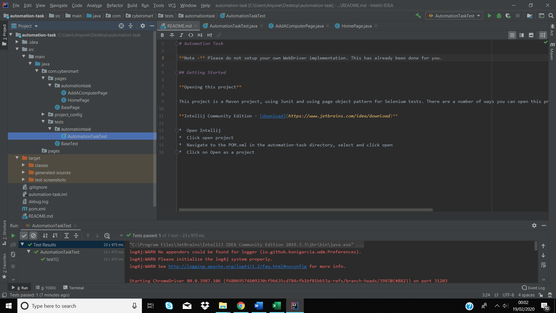

Homepage showing repeated instances of a computer created using automation (Computer name: AAAAA):

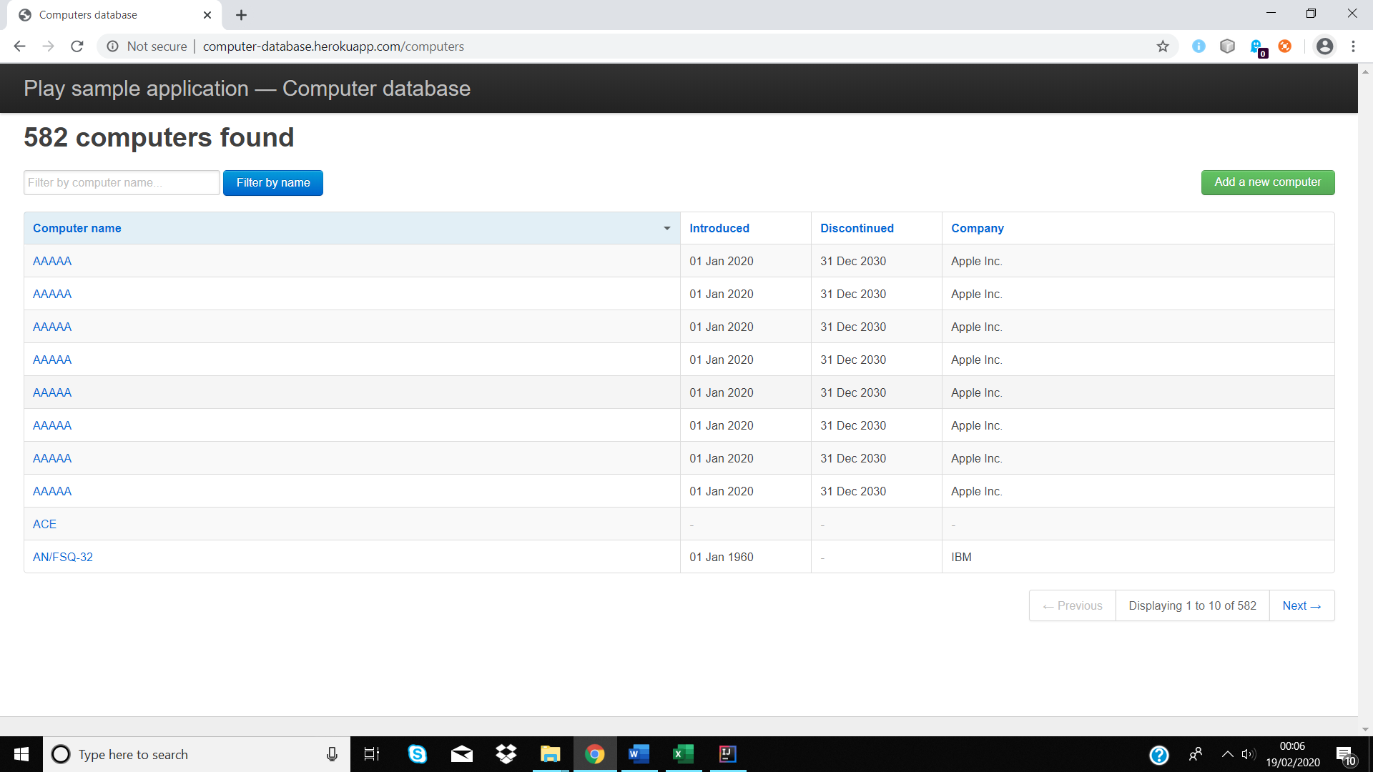

I haven’t created any other automated tests, as the principles behind creating these are broadly similar.